OLNA Skill: Links bearings and key compass directions.

- Are bearings measured in a clockwise or an anticlockwise direction?
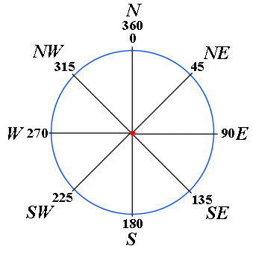
______________________

- How many degrees make up a complete circle? ___________

- If a group of hikers walk on a bearing of 315°, what direction are they travelling in?

________

- What bearing should be set by a ship’s navigator in order to travel due west?

_______________

- The pilot of a plane is travelling in a southwesterly direction. If the navigator turns the plane through an angle of 135° anticlockwise, what direction is the plane now flying in? ___________

- How many degrees are there between west and south east, measured in a clockwise direction? ___________

Terminology:
Bearings provide a way to find directions. They are measured in a clockwise direction from north.
Compasses always point in the direction of north and once the direction of north has been identified it is possible to find the other directions by turning clockwise through the required bearing. For example, facing north and then turning clockwise through an angle of 90° will mean that you are facing east.

